Why trusting odd people on the internet is dangerous.

Trust, is a firm belief in reliability to someone. For example, you can put faith specific individuals which you believe will preserve information at hand. The information which you award to a human could be very personal, and extremely sensitive, so if your fragile information gets into the wrong hands, it could potentially be used against you.
Here is a video about trust on social media.
https://www.youtube.com/watch?v=ZbgDFXxmNuk



Social media is a daily source of information and entertainment that is used globally. Encountering other people is not a bizarre either, we meet new people on a daily basis but trusting them in another issue in itself... like people could hack into your device and gain access to useful and sensitive information about you, if not handled properly, your life and the life of the people around you can be put into immense risks.
For instance, people could pretend to endure habits of a young child and or teenager, effectively luring you into their trap. Usually, these people act slowly but effectively, they gradually gain personal information about you and when it's too late, they'll unfriend you or block you or do many other things preventing you to ever witness them again.


Many parents, especially moms usually prohibit children from playing online games, and or if you acquire a new friend, the mom asks them questions to figure out if they are fraudulent, if the mom accepts the person, the child may resume doing what they enjoy but if moms suspect something awry they could/must prevent the child with ever communicating with the person on the other side of the screen.
Social media interactive websites contain features such as being able to be seen by other people around the world and heard too! As mentioned before they could get ahold of your information.
Some children get training from mentors or parents, for spotting odd people.
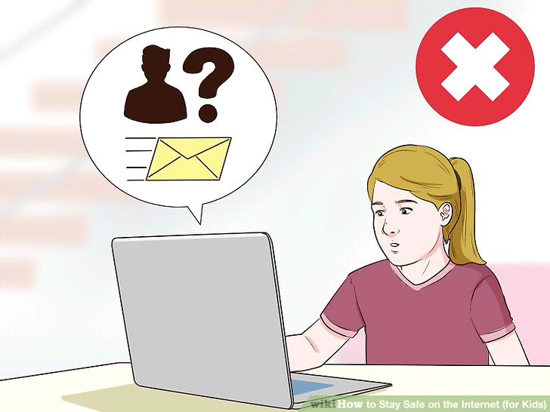

I would recommend this website for further information about why you shouldn't trust people on the internet https://www.psychologytoday.com/blog/close-encounters/201407/can-you-really-trust-the-people-you-meet-online

